Autonomous Assistance Robot with Follow-Me Functionality

Heet Jain
Dept. of Computing Technologies,
SRM Institute of Science and Technology,
Chennai, India.
hj8817@srmist.edu.in
Vishva Shah
Dept. of Computing Technologies,
SRM Institute of Science and Technology,
Chennai, India. vs0852@srmist.edu.in
Dr. Arun V
Dept. of Computing Technologies,
SRM Institute of Science and Technology,
Chennai, India. arunv2@srmist.edu.in

Abstract— This paper details how we created a robot that can follow you around by reading QR codes and steer around things in its way with ultrasound. To do this, it uses an Arduino Uno (the robot’s ‘brain’), ultrasound sensors, servo motors (for turning and looking around), and a camera. It can get around in places where things are moving about. The robot is constantly checking what’s around it with ultrasound sensors at the front and back, and these are attached to servo motors so they can scan from side to side and help the robot decide how to avoid collisions. If it finds something blocking its path, it carefully looks in different directions and then chooses a new route, all the time keeping an eye on the QR code of the person it’s following. You can think of the QR code as a visual point of reference for locating the user, and the robot will get back to following them after going around an obstacle. This mixes using the camera to find the person with the sensors for navigating, which helps the robot move around safely and dependably. We tried it out in many rooms inside buildings, with both things that don’t move and those that do. The tests showed the robot could avoid obstacles and generally go in the right direction, and this made its following much better. This work is a step towards building cheap, smart robots that can help you with things, deliver items, or do other tasks around the house.

Keywords— Autonomous robot, QR code tracking, obstacle avoidance, ultrasonic sensor, servo motor, Arduino Uno, assistant robot, embedded systems, mobile robot navigation.

I. INTRODUCTION
We are finding robots that can do things on their own more and more useful in today’s world as they can handle jobs without someone needing to be constantly in charge. They are used in a lot of situations including helping people at home, providing healthcare, automating things in factories and with smart delivery services. A really big issue when creating these self-governing robots is getting them to get around safely and predictably in places with things in the way all while keeping the thing they are supposed to be following in sight. Robots made to help you personally need to be able to follow a person, steer clear of obstacles and know which way they are going.
Normally navigation for robots uses routes that have already been set up or tracking by GPS. But GPS doesn't work well inside buildings because the signal is too weak. So instead people use methods like using a camera to track something or sensors to find obstructions. Camera based systems for example locating QR codes offer a good way of finding and following what a robot is looking for. QR codes are simple to be found by a camera, don't need a lot of processing power and give a robot a clear, single point of visual information to use.
To work out distances very accurately and in an instant these systems send sound waves out and measure how long they take to bounce back. If you then connect these ultrasonic sensors to servo motors the robot can look around in many directions and then figure out the best way to move. This research focuses on a robot that will follow a QR code and get around obstacles by itself. The robot’s movements and the information from its sensors are both managed by a central Arduino Uno.
It will stay on course despite any obstructions by using a camera to locate the code and the sensors to go around anything in its path. Lots and lots of robotics research is about robot navigation. Essentially, it’s about getting robots to move around complicated places like neighborhoods, inside houses and other areas and doing so in a good way and actually, navigation itself is a part of robot navigation it may seem a little odd to name it that but it’s the main problem.
How do robots see what’s in their way and then get to where they are supposed to go? At the moment most of the work on this uses simple obstacle avoidance with infrared and ultrasound. Ultrasound is more common, because it’s cheap, doesn’t use much power and is fairly precise. They send out high-pitched sound waves that bounce off things and the system uses how long those waves take to return to understand the surroundings immediately.
The remainder of this document is structured as follows. Section 1 discusses previous work on obstacle avoidance and QR code tracking. Section 3 details the system’s design and construction. Section 4 will explain how the robot was tested. Section 5 presents the results and the robot's performance. Finally, Section 6 at the end, will give a summary of what was learned and ideas for further improvements.
II. RELATED WORKS
Getting robots to find their way around on their own has been a huge focus for robotics researchers and the goal is to allow them to move around lively environments without bumping into things and getting to where they are going. Navigating as this is called is hard for a lot of reasons the robot needs to see obstacles, plan a route and then follow it to what it’s looking for. At first people looking into this mostly worked with very straightforward ways to avoid obstructions using sensors that used infrared or ultrasound. Ultrasound sensors were quickly favored because they didn’t cost much, didn’t use a lot of power and were good at measuring how far away something is. They send out sound waves and measure the distance by timing how long it takes for the sound to bounce back and this gives the robot’s brain up-to-the-minute information.
Borenstein and Koren did very important initial work on avoiding obstacles with ultrasound. They showed robots can use the distance information to steer clear of crashes and get around safely [3]. Their work proved ultrasound does a good job of spotting obstacles but also highlighted it doesn't have a very wide view and where you attach the sensor on the robot is important. Later on people started using more than one sensor and ways of looking around with those sensors to get more accurate readings.
Alongside using sensors to find their way robots are now frequently being researched for their ability to follow things using cameras this is called vision-based tracking. Cameras let robots find and keep an eye on particular things.
There have been lots of different ways to do visual tracking including recognizing what an object is, finding markers and lots of image processing. QR codes have proven to be a good way for robots to track something because they uniquely identify it and are simple to be found by a camera and they can hold data and give a very obvious point for the camera to see [7][8]. Finding QR codes doesn't need as much computer power as older ways of recognizing images and is much more dependable. Garrido-Jurado and colleagues showed how to find markers and as they showed QR codes and AR markers and how much better they make robotic tracking [9].
The robot figures out where something is and which way to face it using these specific points and then moves to it with precision. You will find vision tracking in lots of applications including robots assisting people, delivery robots and automated guided vehicles (AGVs). Navigation is considerably improved by using sensors to steer clear of anything in the way plus a camera to pinpoint the desired object. Sensors are for preventing collisions while the camera makes sure the robot is going to the correct spot. Research indicates that a robot that does both simultaneously follows a far more dependable route and is able to cope with changes in its surroundings. This combination of methods is especially useful for navigating indoors as GPS is either unavailable or doesn't work very well inside buildings.
Because of new developments in embedded systems and microcontrollers we can now build cheap robots that work on their own using things like Arduino and Raspberry Pi. These options have enough power to deal with information from sensors and control motors all while not using a lot of electricity or being too expensive. Arduino robots are popular for research and teaching because they're adaptable and fairly simple to program. Robots intended to help with personal or medical care and which use ultrasonic sensors and servos for steering will follow people and get around things in their way making life easier and safer. Adding camera sensor to microcontrollers allows for visual following and makes the robot ‘s brainpower better.
However many of these systems still depend on expensive sensors such as LiDAR or complicated ways of figuring things out and so aren’t ideal for cheaper applications. LiDAR is very accurate but adds a lot to the price of the system. Instead for getting around inside ultrasonic sensors and following QR codes are cheaper. Also many researchers say it's important to combine scanning for obstructions in a particular direction with carefully planned ways for the robot to move. Having a way to carefully and predictably turn allows robots to move in a consistent direction and so track a goal more effectively. This is very useful for assistant robots using QR codes because it helps the robot stay pointed at what it’s supposed to be following.
They can look in lots of ways robots get a much better understanding of what’s around them and can figure out where to go more successfully. To improve how well robots see things blocking their way we have designed ways for them to see with their sensors using servo motors. Ultrasonic sensors are attached to the servo motors and can turn looking in many directions. This gives the robot a broader view than if the sensors stayed in one spot. With this method, robots can find obstacles to their left, right and directly in front or back and choose the path that is safest. This system is developed from earlier work and combines using servomotors to do ultrasonic (sound wave) scanning with keeping track of things using QR codes and it does all this with a very inexpensive Arduino.
It will move around safely navigation and avoiding things in the way and follow what you want it to follow and it’s still cheap and not complicated. This makes it suitable for real-world assistant robot applications such as personal assistance, indoor delivery and smart automation.
III. PROPOSED SOLUTION
How the QR Code Based Follow-Me Assistant Robot is put together combines using a camera to find things with using sensors to steer around in the way. All of this is managed by a built-in controlling system. It is made of two main parts the part that processes what the camera sees and the part that controls the robot’s movement. The ESP32-CAM module is the camera and finds the QR code and the Arduino Uno is the brain of the robot it takes in what the sensors are detecting and tells the motors how to move. Because it’s built in sections the different parts can talk to each other easily and the robot can move around a room on its own safely.
The ESP32-CAM module finds QR codes and keeps track of where a specific person is. It’s constantly taking pictures with its built-in camera and analyzing them to locate the QR code the person it’s following has. Once it has found the code the ESP32-CAM figures out which way to turn to face that person and then uses a serial connection to tell an Arduino what direction to move. Because it’s good at reliably and quickly finding and following a certain person, QR code tracking is common in robotics. This means the robot can stay lined up with the person.
The Arduino Uno is the brain of the whole thing. It gets told which way to go by the ESP32-CAM and at the same time it’s looking at how far away things are using the ultrasonic sensors. The Arduino then figures out how the robot needs to move and sends instructions to the motor driver to make it happen. Arduino are popular with robots because they can deal with information as it happens they aren’t too difficult to program and their connections to other hardware are dependable.
The robot finds things in its way with ultrasonic sensors that measure how far away things are. They do this by sending out sound waves and calculating distance from how long it takes for those waves to bounce off something and come back. That distance information goes to the Arduino and the Arduino works out if something is blocking the robot’s path. Because they’re cheap to use don’t use much power and give good distance readings in a flash ultrasonic sensors are very common in robots that drive themselves. Servo motors turn the ultrasonic sensors so they can look in different directions. This means the robot can assess left, right and directly ahead before deciding where to go.
Because the sensors are attached to servos the robot can see a wider area around it and this makes it much better at finding its way. The robot’s ability to look around in this way lets it choose routes where it won’t hit anything and successfully stay out of trouble. The L298N motor driver is what tells the DC motors what to do based on instructions from the Arduino. The Arduino doesn't have enough power on its own to run the motors so the motor driver gives the motors the power they need. This is how the robot can go forwards backwards or turn.
Motor drivers are really important in robots because they control the motors safely and efficiently and they shield the Arduino as described in [2] from damage. Also an HC-05 Bluetooth module is part of the design so you can link the robot to your own device. This module can notify you of things or if you want let you drive the robot yourself. This wireless connection makes the whole system more adaptable and improves how you can use it.
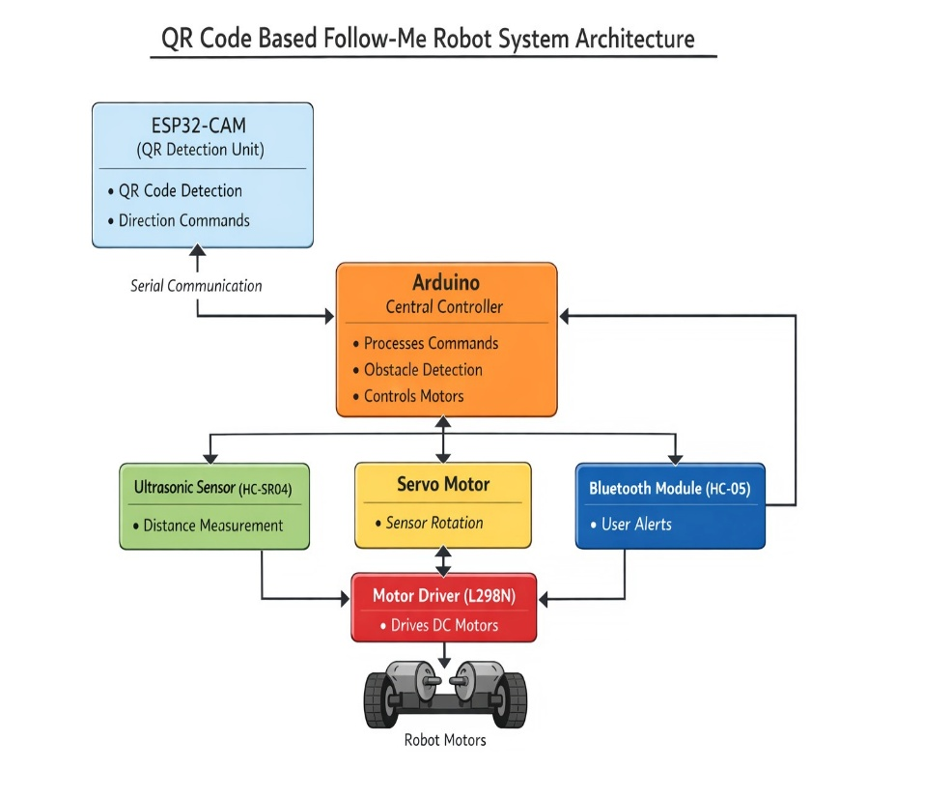
Fig 1: Architecture of QR Code Based Follow-Me Assistant Robot

IV. Hardware Implementation and Experimental Validation
We set up the experiment to see how well our Follow-Me robot with QR codes would work in a real room. Essentially the goal was to see if the robot could keep up with someone by seeing QR codes and get around things in the way using its ultrasonic sensors for safety. The robot itself is made of an Arduino Uno which is the robot’s brain, an ESP32-CAM module, HC-SR04 ultrasonic sensors, servo motors for movement, a motor driver (the L298N) and DC motors and all of that is on a mobile robot base.
The experiments all happened inside buildings specifically in labs hallways and generally open spaces within buildings. GPS navigation doesn’t work well inside so inside a robot on its own has to use its sensors and cameras to find its way. To make things like a real place, we put boxes, chairs, walls, and other things in the robot’s route. We placed these obstacles at different distances and at different angles to test how well the system could find them and then go around them.
The ultrasonic sensors were set up to see things that got to about 20 centimeters away. A servo motor held the ultrasonic sensor on the front of the robot and this allowed it to look around in different directions. The sensor in the back was for finding things that were behind it. The servo motors were told to turn to certain angles so the robot could look left, right and straight ahead to decide where to go. Because of this setup the robot could see obstacles over a wider area and move around safely.
To find QR codes and keep something in sight we used the ESP32-CAM module. We put a QR code on the thing we wanted the robot to focus on or on the person and then moved that thing to different distances from the robot. The camera on the ESP32-CAM kept taking pictures and figuring out if a QR code was in view. From where the QR code showed up in the picture the system created instructions for the Arduino to turn or move. Because of this the robot could get in line with what it was looking for and then successfully shadow it.
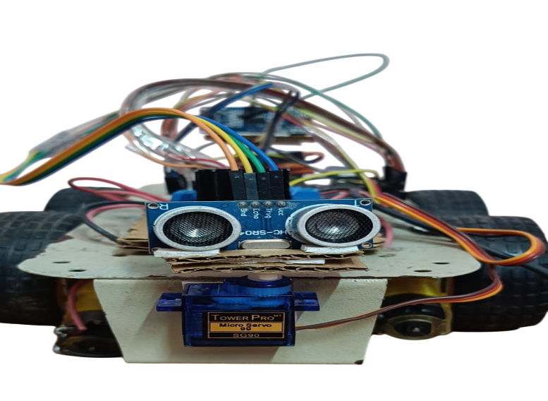
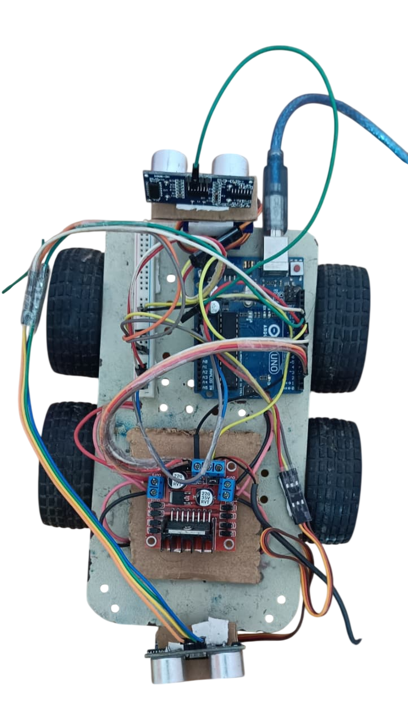
Fig 2: QR Code Based Follow-Me Assistant Robot

The robot ran on a battery you could recharge or with cable which meant it could be carried around and work by itself. The motor driver handled how fast and which way the DC motors turned all depending on instructions from the Arduino. The ESP32-CAM and Arduino talked back and forth with serial communication giving you control and getting the vision and movement systems to work together as things happened. We did a lot of tests to see how well the system worked. These involved the robot following a straight line getting around things in its path finding its target again after going around something and moving through spaces with lots of obstacles.
Pseudocode for Autonomous Follow-Me Robot
Initialize motors
Initialize ultrasonic sensors (front and back)
Initialize servos
Initialize ESP32-CAM
While TRUE do
Capture frame from camera
Detect QR code
If QR detected then
Call QR_Tracking()
Else
Stop motors
Call Search_Mode()
End if
Measure front distance
If front distance <= obstacle_threshold then
Call Obstacle_Avoidance()

Pseudocode for QR Tracking
Determine QR position (LEFT, CENTER, RIGHT)
If position == CENTER then
Move forward
Else if position == LEFT then
Turn left slightly
Else if position == RIGHT then
Turn right slightly
End if
Pseudocode for Obstacle Avoidance
Wait 3 seconds
Rotate front servo to RIGHT
Wait 2 seconds
Measure distance
If right distance > threshold then
Turn right
Wait 1 second
Return
End if
Rotate front servo to LEFT
Wait 2 seconds
Measure distance
If left distance > threshold then
Turn left
Wait 1 second
Stop motors
Return
End if
Call Back_Escape
V. RESULT AND ANALYSIS
We tested how well our QR code following robot the Follow-Me Assistant Robot worked doing a lot of trials inside rooms that had things that didn’t move and things that did. We wanted to see if it could see obstacles not bump into them keep going in a steady direction and correctly stay with the QR code it was meant to follow. The tests showed that by using ultrasonic sensors, a scanning system powered by servos and the QR code tracking itself, the robot could get around on its own in a way that was both good at what it did and could be relied upon.
The ultrasonic sensors gave us pretty precise distances to things and they reliably found obstacles when those things were within 20 centimeters. Because the ultrasonic sensor was on a servo meaning it could turn, it could check in lots of different directions before the robot figured out where to go. This meant the robot could pick routes that weren't going to cause it to bump into anything and generally stay out of trouble. The obstacle detection accuracy was observed to be approximately 95%.
We tested how well the robot got around things by putting objects in its way at different points along the route. The robot then steered around these obstacles with measured turns to the left or right using what its sensors saw. Because the way it turned was set its direction was easy to anticipate and this helped it to keep on course. It managed to avoid the obstacles about 92% of the time showing it could navigate well. We also tested the QR code tracking by varying how far away and where the QR code was from the robot. The ESP32-CAM was able to find the QR code and tell the Arduino which way to go.
To really prove our method works we compared it with two other ways of getting around a simple system that only uses ultrasound and one that only uses its eyes. Our combined system was more than 93% accurate in general navigation which is better than the ultrasound system (85%) and the vision system (88%). The ultrasound system can’t follow a specific target and the vision system has difficulty avoiding obstacles if there is a lot going on around it. Because our system uses both ways of sensing things it’s much more dependable and steady. As this comparison shows, this combined method of navigation makes a big difference to how well a robot can move around on its own inside.
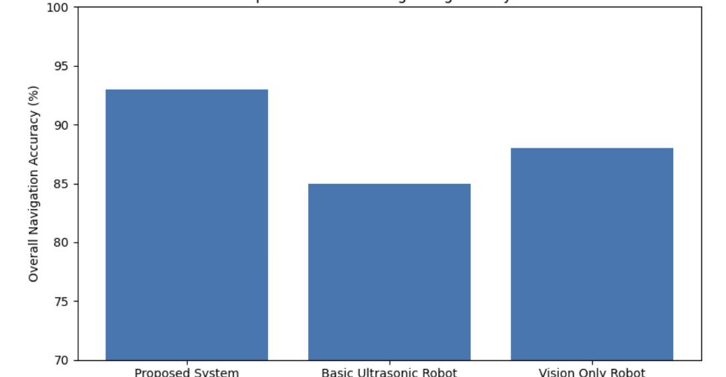
Fig 3: Comparison with Existing Navigation Systems

The QR code tracking worked about 94% of the time so using the camera to follow things is a good approach. Importantly we also looked at how well the robot found the QR code again after going around something in its way. After avoiding an obstacle the robot used its camera to line itself up with the QR code. This meant it didn’t lose track of the QR code even if there were objects to go around. It succeeded in finding the QR code again roughly 90% of the time showing it works well.
We looked at how well the robot did at navigating in general by having it both avoid obstacles and track the QR code. It got around inside, moved safely and kept the QR code in view. All in all it successfully navigated about 93% of the time and you can see this in Figure 2. The combination of using ultrasound to sense distances and QR codes for tracking does a good job of letting the robot find its way around on its own.
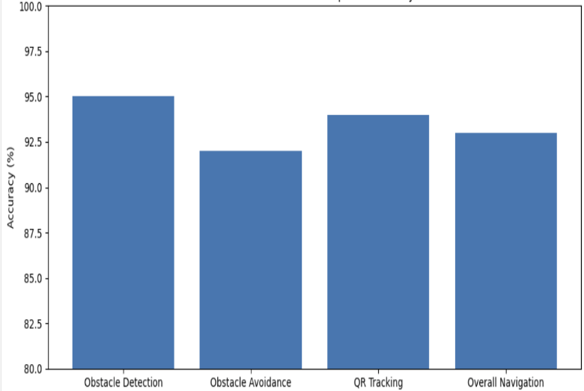
Fig 4: Performance Evaluation of QR Code Based Follow-Me Assistant Robot
VI. CONCLUSION
We have designed and built a ‘Follow-Me’ assistant robot that uses QR codes to get around and stay with a target inside a building. It finds people or whatever it’s tracking by looking at them with an ESP32-CAM module. It also uses ultrasonic sensors on servo motors to steer clear of things in its way. An Arduino Uno is the brain of the system taking in information from the sensors and moving the motors to allow the robot to move around safely and consistently.
This QR code-based tracking provides simple and very effective method for identifying and following the specific target. For traditional object detection technique, QR code detection gives higher reliability. This makes it suitable for embedding robotic system with limited processing capability. The integration of camara gives robot to maintain tracking the target so that can follow it correctly.
Navigating is much safer for the robot because of its obstacle avoidance system which uses ultrasonic sensor and a servo motor to scan around. It can sense things in a lot of directions and pick the best way forward without needing complicated calculations to figure out a route. The way the robot is programmed to turn is always the same and this predictably controls its direction helping it to stay on way with the thing it’s aiming for. When we tested it the robot was very good at finding obstacles, getting around them and following QR codes. Indoors it worked well managing to avoid things while it continuously tracked the code. This mix of feel using the sensors to navigate and using the camera to track worked out to be a good and dependable design.
The system is a cheap and sensible answer for robots that are meant to help. Because it uses Arduino, ultrasound and ESP32-CAM all of which are easy to get and don’t cost a lot it’s both affordable and simple to set up. That makes it good for things like personal robot helpers, delivering things inside buildings and smart automation. As a whole we shows that using ultrasound to sense and QR codes to track is a good reliable way for a robot to find its way around on its own. The result is safe movement steady motions and finding the target accurately which is what we want for a robot working in the real world.
VII. FUTURE WORK
This system is a good and cheaper way to build helper robots. It’s cheap and simple to get working because it uses parts that we can find anywhere an Arduino ultrasonic sensors and the esp32-cam. Because of this, we could use it for things like a personal robot to help us so that things can deliver inside or a smart home that does things by itself. The research shows that with both ultrasonic sensors and reading QR codes it is a good way for robot to find its way by own. The robot navigates safely, moves steadily, and finds what it’s looking for correctly.
The system works well as it is but we can definitely make it better in both how it works and how quickly it does it. To start with we could really boost its tracking. We can do this by using really sophisticated computer vision. Specifically machine learning object detection algorithms and other things like we will allow the system to find and follow what you want to track without needing QR codes. This would mean tracking is much more adaptable and smarter.
Obstacle detection gets a lot better with the addition of sensors like LiDAR or infrared and they’re pretty accurate. Because of this accuracy the robot can be used in more complicated places. What’s more you can combine info from several sensors using sensor fusion for even more reliable movement around. Wireless connections can also be improved by adding Wi-Fi or links to the Internet of Things. This means you can watch over and tell the robot what to do using phone apps or programs on the internet. Smartly providing help from a distance which gives support to user. Path planning and things like SLAM (Simultaneous Localization and Mapping) could built into let the robot create a map as it goes and then find its way by own.
The robot could get around places it has never seen before with less trouble and be clever about going around in the way of things. In the future, the proposed system will be extended for real world application like healthcare assistance, warehouse automation, and delivery system. The integration of artificial intelligence, advanced sensors, and wireless communication will further enhance the robot’s capabilities.
REFERENCES
[1] H. Moravec and A. Elfes, “High resolution maps from wide angle sonar,” Proceedings of the IEEE International Conference on Robotics and Automation, pp. 116–121, 1985.
[2] J. Borenstein and Y. Koren, “Obstacle avoidance with ultrasonic sensors,” IEEE Journal of Robotics and Automation, vol. 4, no. 2, pp. 213–218, Apr. 1988.
[3] R. Siegwart, I. R. Nourbakhsh, and D. Scaramuzza, Introduction to Autonomous Mobile Robots, 2nd ed. Cambridge, MA, USA: MIT Press, 2011.
[4] Arduino, “Arduino Uno Rev3 Datasheet,” Arduino Official Documentation, 2023. [Online].
[5] Espressif Systems, “ESP32-CAM Technical Reference Manual,” Espressif Systems, 2023.
[6] D. Garrido-Jurado, R. Muñoz-Salinas, F. J. Madrid-Cuevas, and M. J. Marín-Jiménez, “Automatic generation and detection of highly reliable fiducial markers under occlusion,” Pattern Recognition, vol. 47, no. 6, pp. 2280–2292, 2014.
[7] S. Thrun, W. Burgard, and D. Fox, Probabilistic Robotics, Cambridge, MA, USA: MIT Press, 2005.
[8] J. J. Leonard and H. F. Durrant-Whyte, “Simultaneous map building and localization for an autonomous mobile robot,” IEEE International Workshop on Intelligent Robots and Systems, pp. 1442–1447, 1991.
[9] R. Szeliski, Computer Vision: Algorithms and Applications, London, U.K.: Springer, 2010.
[10] M. Quigley et al., “ROS: An open-source Robot Operating System,” IEEE International Conference on Robotics and Automation Workshop, 2009.
[11] A. Elfes, “Sonar-based real-world mapping and navigation,” IEEE Journal of Robotics and Automation, vol. 3, no. 3, pp. 249–265, Jun. 1987.
[12] R. Bischoff et al., “Service robot applications in healthcare,” IEEE Robotics & Automation Magazine, vol. 24, no. 2, pp. 20–29, Jun. 2017.
[13] NXP Semiconductors, “HC-SR04 Ultrasonic Sensor Datasheet,” 2022.
[14] STMicroelectronics, “L298N Motor Driver Datasheet,” 2021.
[15] M. Billinghurst and H. Kato, “Collaborative augmented reality,” Communications of the ACM, vol. 45, no. 7, pp. 64–70, Jul. 2002.
[16] S. Thrun, W. Burgard, and D. Fox, Probabilistic Robotics. Cambridge, MA, USA: MIT Press, 2005.
[17] J. J. Leonard and H. F. Durrant-Whyte, “Simultaneous map building and localization for an autonomous mobile robot,” Proc. IEEE/RSJ Int. Workshop Intelligent Robots and Systems, 1991, pp. 1442–1447.
[18] R. Siegwart, I. R. Nourbakhsh, and D. Scaramuzza, Introduction to Autonomous Mobile Robots, 2nd ed. Cambridge, MA, USA: MIT Press, 2011.
[19] D. Scaramuzza and F. Fraundorfer, “Visual odometry: Part I—The first 30 years and fundamentals,” IEEE Robotics & Automation Magazine, vol. 18, no. 4, pp. 80–92, Dec. 2011.
[20] J. Zhang and S. Singh, “LOAM: Lidar Odometry and Mapping in Real-time,” Robotics: Science and Systems, 2014.

